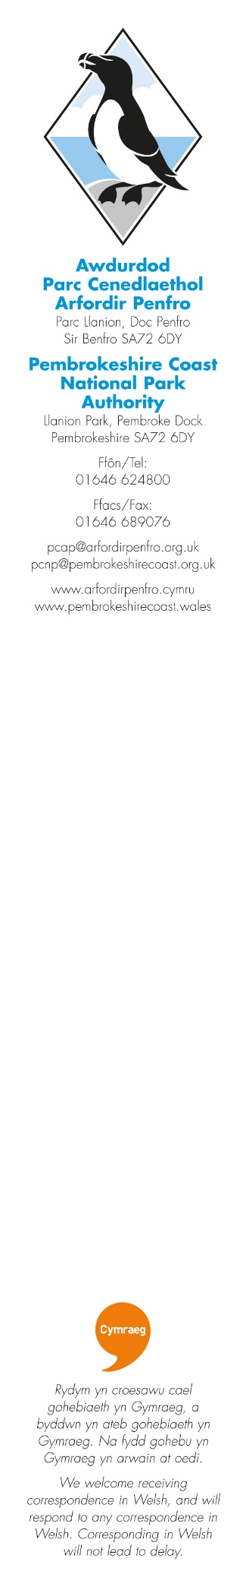
July 2024

Dear Sir/Madam
Pembrokeshire Coast National Park Consultation on the Proposed Cresswell Quay Conservation Area

At the National Park Authority’s meeting on 24th July 2024, it was considered that Cresswell Quay and its immediate environs should be designated as a Conservation Area along with the fourteen existing within the National Park Authority.
The Authority is welcoming your comments on the proposed Conservation Area designation.
Please complete the online questionnaire with your views on the proposed designation. A map of the proposed Conservation Area Boundary and further information can be downloaded from the National Park Authority website at www.pembrokeshirecoast.wales/get-involved/public-consultations/
Alternatively, you may make your views in writing to the Strategic Policy Team, Pembrokeshire Coast National Park Authority, Llanion Park, Pembroke Dock, Pembrokeshire, SA72 6DY or via email to devplans@pembrokeshirecoast.org.uk.
The consultation period will run until 5 p.m. on Monday 23rd September 2024.
All representations will be acknowledged and will be made public. All representations will be reported to the National Park Authority. To be informed of the outcome of the Authority meeting, representors are advised to include their contact details in the online questionnaire. Alternatively, you can request to be included in the Authority’s mailing list by emailing the Strategic Policy team at devplans@pembrokeshirecoast.org.uk.
The National Park Authority will also be holding a drop in engagement event at Pisgah Chapel on 8 August from 3pm to 7pm. Officers will be available to answer questions.
If you have any further queries, or require any additional information, please call us on 01646 624800 to contact the Strategic Policy Team or email devplans@pembrokeshirecoast.org.uk.

Yours sincerely
Emma Gladstone
Emma Gladstone
Strategic Policy Manager
Pembrokeshire Coast National Park Authority

